**How to create and view grades**

1. First, select gradebook tab.

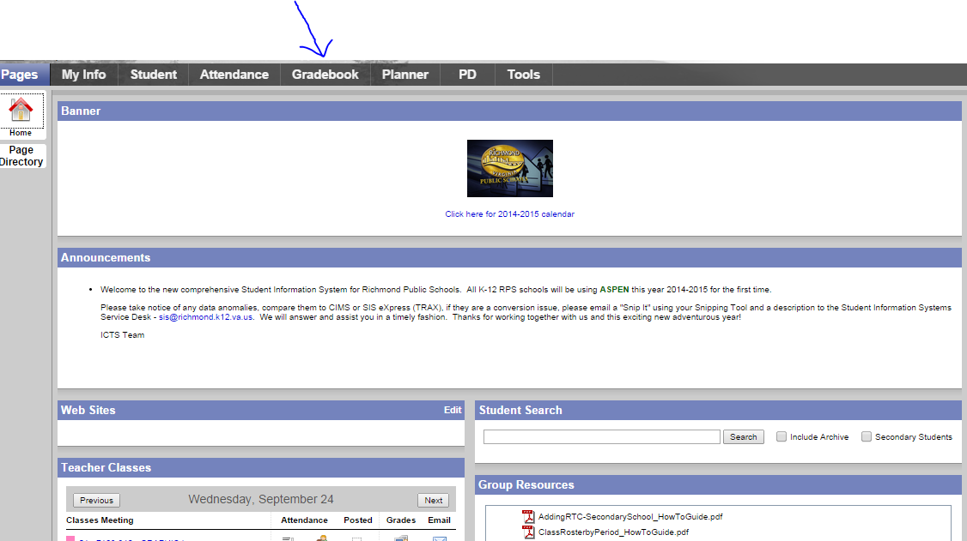

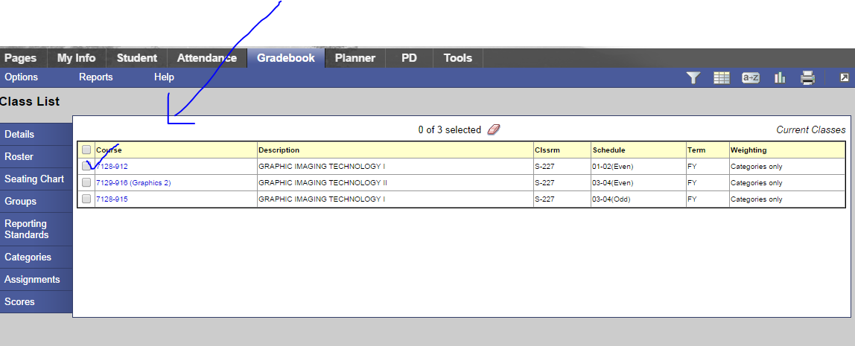

2. Next, select the class you would like to add a grade to.

4. After you have selected the assignment tab down below, choose “options,” and in the drop down menu, select “Add assignment.”

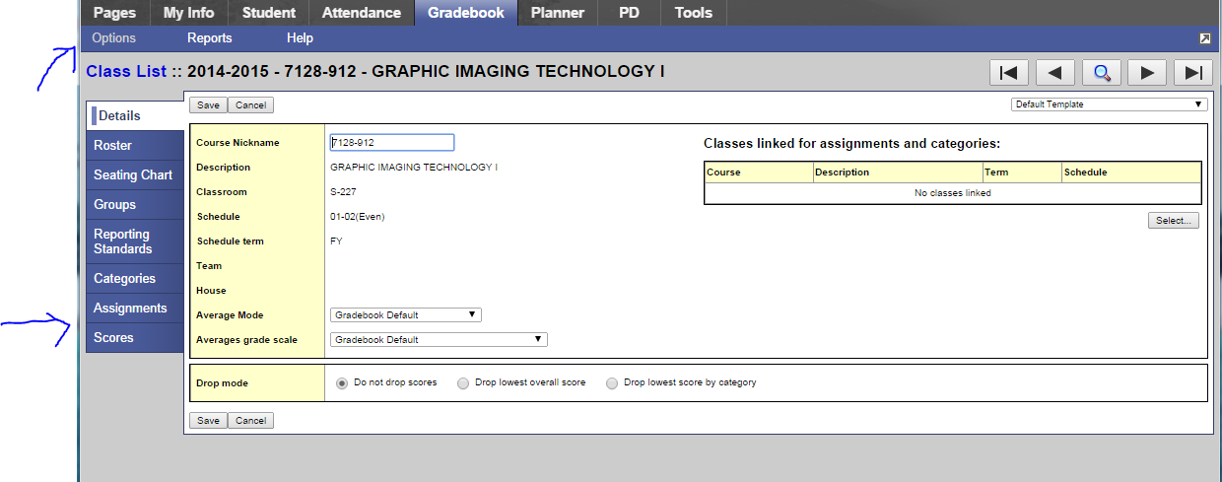

3. Once you get to this screen, select assignment.

5. After you of have chosen to add an assignment (demonstrated above) you are brought to this screen to enter in your assignment information. Fill out all required fields indicated by the red astrix.

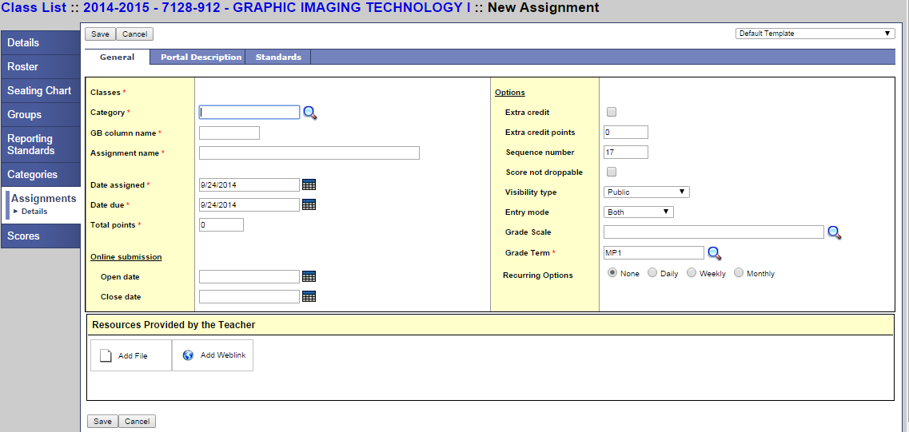

6. After you have all of your assignment information complete. Click SAVE!

F. Click on the magnifying glass and select MP1 for the first marking period.

E. Choose your total points. For example100. You may see a number automatically depending upon how you set up your gradebook preferences.

D. Select your due dates.

C. Name the assignment.

B. Name your grade book column. Its recommended to name it by the CTE or SOL.

A. Click on magnifying glass and select a category you have created.

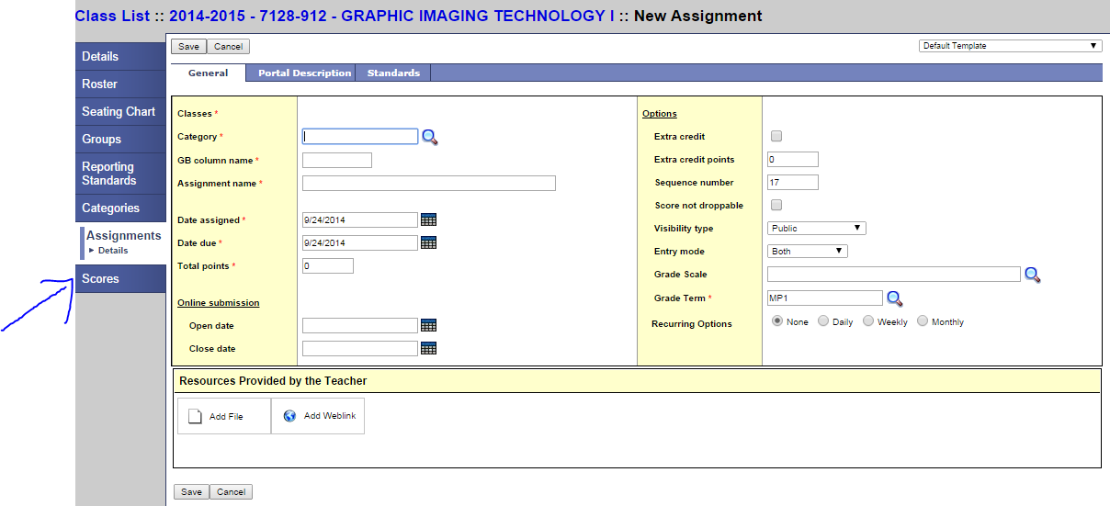

7. After you have SAVED the assignment. Click over on the “scores” tab.

8. After you selected “scores” you are brought to this screen. Make sure, here, you choose the drop down menu indicated by the arrow. If you select “All” **all** your categories and **all** your assignments will appear. If you created an assignment and it is not displaying, its probably because you are not in the correct category, or you have another option selected such as “post columns” or “averages.”

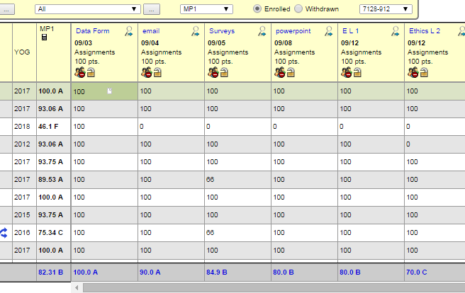

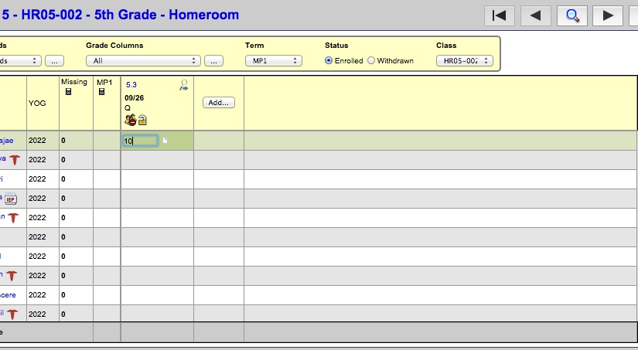

9. To enter in scores, click in the assignment column you just created. You can choose to tab down to enter them one by one- or to duplicate. To duplicate a score you can press CTRL D at the same time, for example if I want to have a score of 10 copied to every student. Keep in mind you can type over top of the grades to edit.



10. You can also click add here on “Add” to add a new assignment.