ASPEN: Weighted grades

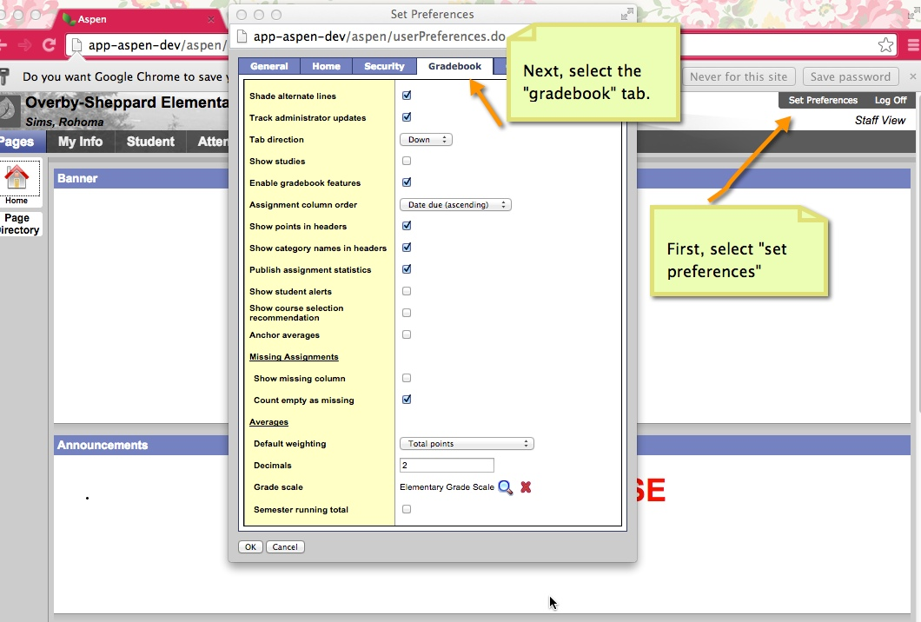

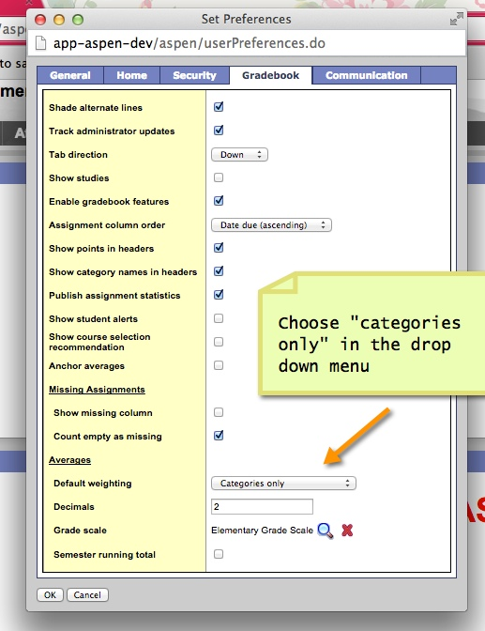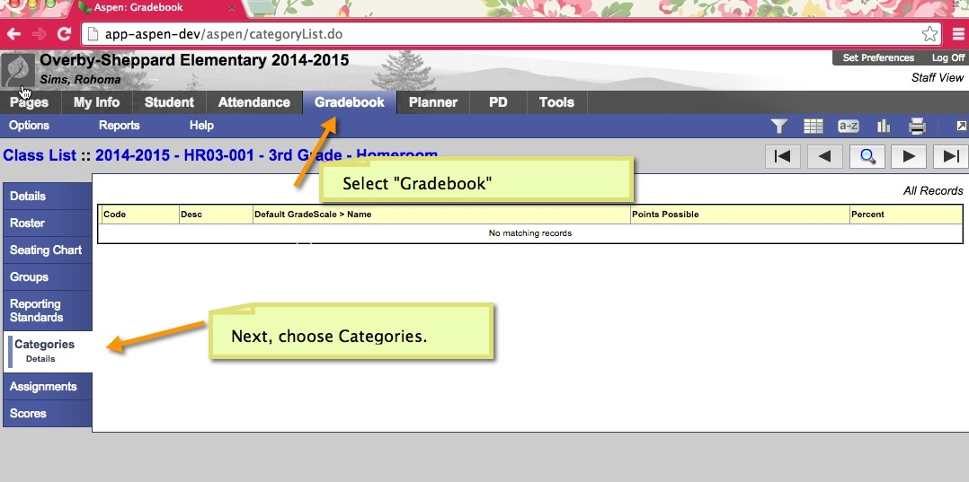

Click “Ok” when finished

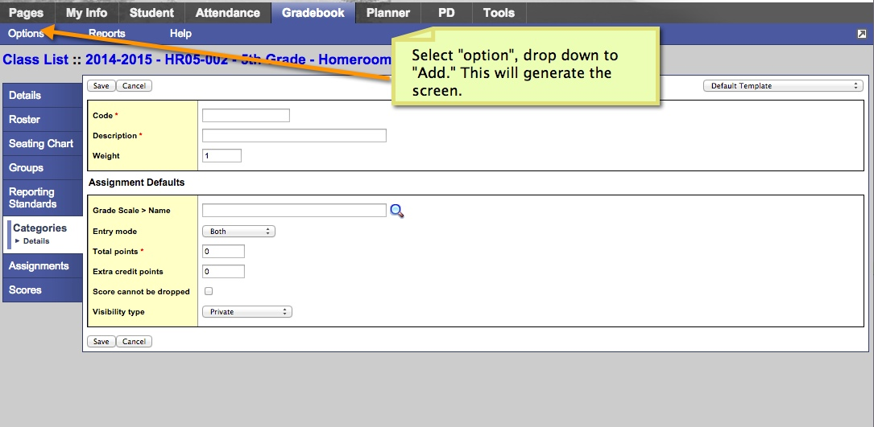

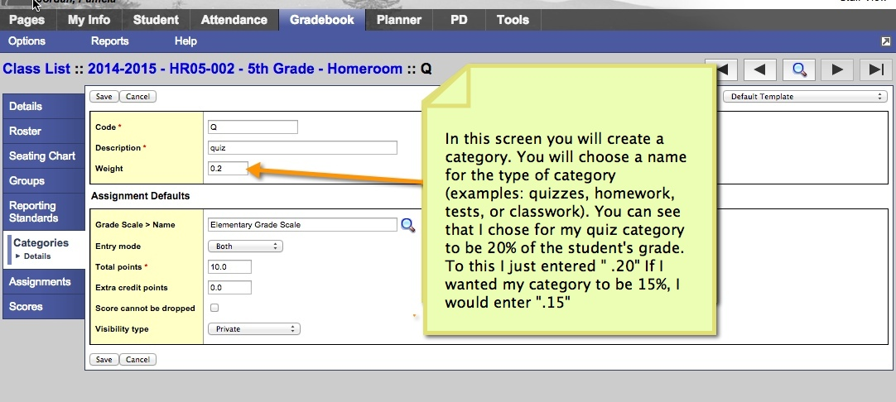

**Make sure select “save” when you are finished creating the category.**

**\*If you require further assistance for explanation in creating categories please view either the help videos I have provided on my webpage or in the Apsen Help menu.**

